Route Tools Extension Documentation
Version 2.1
October 10, 2003

This document is meant as a rough guide to the functionality contained in the RouteTools (Vers. 2.1) ArcView 3.x Extension. This is meant to be a quick guide to the tools and their functionality. Each tool/function is described, and there is a guide to common functions at the bottom of this document.
The RouteTools extension was developed by Eric Haney CDFG-NCNCR to enable the rapid development of stream event information. The tools are designed to allow users to collect geographic referencing information (events) that can be related to any survey information, observation data, or stream attribute information (e.g., habitat data).
In most cases, the tools contained in the RouteTools extension request an EventID from the user. This EventID should be used as the linkage between the event data generated by the extension and the non-spatial survey or stream attribute information. Every attempt should be made by the user to ensure that the EventID is unique.
The RouteTools extension is designed to work in conjunction with the routed hydrography that has been developed and/or modified by NCNCR-ISB. Currently there is a 1:100k hydrographic dataset that encompasses all Hydrographic units that are classified as having Anadromous fish. It is anticipated that this dataset will be expanded to cover the entire state over the next few months. There is also a modified 1:24k hydrographic dataset that was developed by CDF for the North Coast Watershed Assessment Program. Not that much of the functionality of the Extension requires that one of the above hydrographic datasets be added to the project and selected as the Active Theme.
The RouteTools extension also provides limited functionality for adding linework to the Hydrographic datasets described above. These Hydrography tools alow the user to add linear features (via heads-up digitizing) that can be inserted into the hydrographic database. When used correctly, these tools will insert the line into the database, route the line, and calculate various stream properties for used by the event mapping tools. Please note that it is the user’s responsibility to track and maintain their additional linework. As new hydrographic datasets are made available, users who have added linework will need to transfer their custom linework to the new datasets. If you are interested in working with or developing hydrography, we have developed a more robust series of ArcView tools and incorporated them into a HydroTools Extension. Please contact Eric Haney (ehaney@dfg.ca.gov) for more information.
Finally, the RouteTools extension has functionality to enable users to “crosswalk” their existing events from one hydrographic dataset to another. This functionality is critical for users who already have events mapped on the older 1:100k hydrography. Please contact Eric Haney for more information about this.
We will be working in the coming months to develop these same tools for use in ArcGIS 8.x . Please stay tuned.
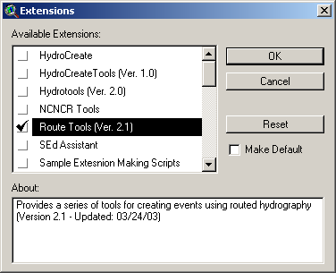

As with all ArcView extensions, the RouteTools extension must be added to the project. Add the extension by selecting File:Extensions and then placing a check mark in the box next to “Route Tools (Ver. 2.1). Once added, virtually all of the tools are all accessible from the View object. The tools include a RouteTools menu, a HydroTools menu, and three additional ArcView Tool buttons. Additionally, there is a RouteTools menu added to the Table Object.
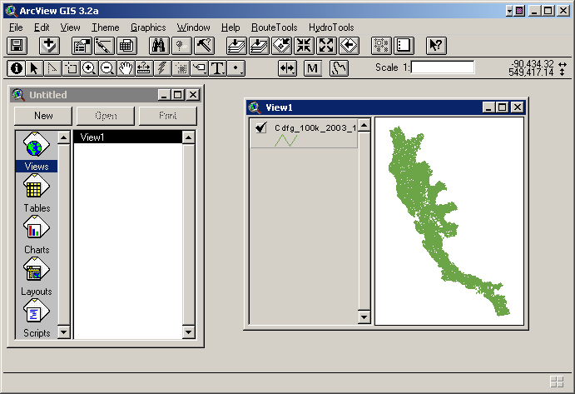
The following tables briefly describe the functionality of each of the menu items and tools.

RouteTools Menu (View object)
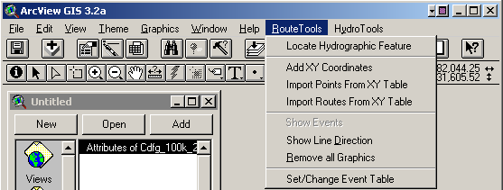
Locate Hydrographic Feature | This item presents a dialog box that allows the user to search the active Hydrographic Layer for a stream name or LLID. It automatically searches the “Name” and “LLID” fields in the attribute table, but the user can optionally have it also search the “Down_name” and “Down_LLID” fields. The user can zoom to any of the records returned by the query by double-clicking on the record of interest.
Add XY Coordinates | This item adds x and y coordinate information to any active point or line theme. For point themes, it adds a “FromX” and FromY” field and populates these with the point coordinates. For line themes, it adds a “FromX”, “FromY”, “ToX”, and “ToY” Field, and populates these with the beginning and ending coordinates of the linear feature. This item is designed to facilitate the crosswalk of events from one Hydrographic dataset to another. By adding this information to an event theme, the user can then use the “Import Routes From XY Table” to transfer the events to a new Hydrographic Dataset. Note that sometimes the original event table will appear scrambled after adding the coordinate information. If this happens, simply delete the table and then add it back to the project. This bug should be fixed in a later release.
Import Points From XY Table | This menu item is meant primarily as a diagnostic tool for transferring events between hydrographic datasets. It simply reads the coordinates from the FromX, FromY, ToX, and ToY fields and creates a point shapefile so that the user can observe the events (as points) in the view.
Import Routes From XY Table | This menu item allows the user to create routed events from coordinate information. Once selected, this menu item prompts the user for which table the coordinate information is in, which field in that table contains the EventID, which fields contains the FromX data, FromY data, ToX data (optional) and ToY data (optional). For linear events, the user must select the ToX and ToY fields, but these should not be selected if the event is a point event (e.g., a barrier or observation). This functionality can be use in conjunction with the “Add XY Coordinates” function to crosswalk events from one hydrographic dataset to another. Note that this function creates and additional “Problems” shapefile that indicates where Event Coordinates could not be mapped to the hydrography.
Show Events | This function requires that the Hydrographic Theme be the active theme and that the user has established (set) an event table. Once implemented, this function will create an event theme from the current event table. It automatically creates linear events (if there is a value for the EndFt Field) and point events. Note that users have experienced some “buggyness” with this function. At times, not all of the events will be shown. It is recommended that the user convert the event theme to shapefile to ensure that all events can be viewed. Also, the event theme(s) that are created are static and will not be updated if the user adds additional events to the underlying event tables. To view newly created events, it is recommended that you delete the old event themes and then use the “Show Events” function again to re-create the event themes.
Show Line Direction | This function simply alters the symbology of the hydrographic theme so that it displays direction arrows. Note that the direction arrows do not indicate stream flow direction, rather, they indicate the route direction (from the mouth to the headwaters). This tool is primarily used to help the user visually determine route direction.
Remove All Graphics | This function removes all graphic objects from the View. Each time that an event is created using the event mapping tools (described below), graphics are added to the view to indicate the location of the beginning and ending points for the event (if linear). These are just dumb graphics (no attributes associated with them), and can clutter up the screen if the user is creating a lot of events. The “Remove All Graphics” function allows the user to simply delete them all from the view.
Set/Change Event Table | This function allows the user to select (set) or change the active event table. It brings up a dialog box that allows the user to select from a list of all valid event tables in the project. It also allows the user to create a new event table. Once an event table is selected (or created), it then becomes the active event table into which all new events are written.

HydroTools Menu (View Object)
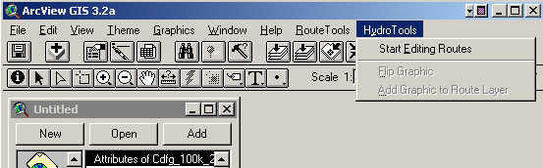
Start/Stop Editing Routes | This function allows the user to edit the active routed hydrographic dataset in a limited fashion. This works similar to the Theme:Start Editing function, but works only for routed layers. ArcView 3.x does not come standard with functionality that allows you to edit routed (PolyLineM) themes. Because of this, our capabilities for modifying the hydrographic data were initially limited. Fortunately, we were able to modify the underlying functionality so that we could perform simple edits (e.g., adding or deleting routes). The user cannot edit edit existing linework (e.g., move or delete vertices), but you can create lines and insert them into the dataset and you can delete lines. Once this function has been chosen, it will change to read “Stop Editing Routes”.
Flip Graphic | This function allows you to “flip” the direction of a graphic. This can be used after the user has digitized a new stream to add to the hydrography. This should be used to ensure that the route is oriented so that the beginning is at the mouth of the stream and the end is at the headwaters. Again the route direction must be opposite of stream flow. This is counter intuitive, but necessary to ensure that the hydrography and associated events work correctly.
Add Graphic to Route Layer | This function adds a digitized stream to the hydrography layer. Once a stream has been digitized using the “Stream Digitizer” tool, and it has been oriented correctly using the “Flip Graphic” function (if necessary, this function will insert it into the hydrography layer, route the linework, and calculate the various stream parameters. Note that this function will only be accessible if the hydrography layer is editable.

RouteTools Menu (Table Object)
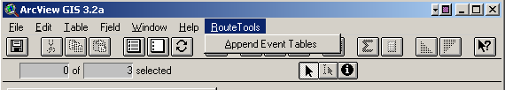
Append Event Tables | This function allows the user to append multiple event tables into one. The user is prompted to choose which table is the master table (the one where everything is appended to) and is then prompted for which other tables to append. This function is only available if there is more than one event table in the project.

Tool Buttons (View Object Toolbar)
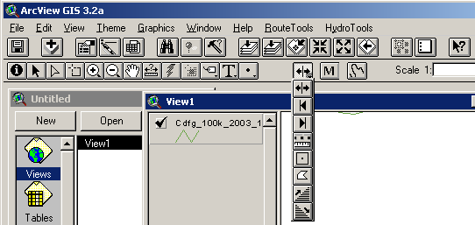
Measure Tool | Reports the measure of a stream (in feet and miles) at the point where the user clicks. Also reports the LLID of the stream. Output is reported at the bottom left of the ArcView window.
Stream Digitizing Tool | This tool is used to heads-up digitize new streams for inclusion into the hydrography. Essentially the result is a simple linear graphic in the view that can be flipped and/or added into the hydrography.  Note that care should be taken to digitize linework at an appropriate scale and to make sure that the mouth of the stream is very near the stream in which it flows into. The mouth of the stream will be snapped to the downstream feature if it is close enough.
Whole Stream Tool | Creates an event in the active Event Table that encompasses the entire stream from mouth to headwaters.
Downstream Tool | Creates an event in the active Event Table from the user click to the mouth of the stream.
Upstream Tool | Creates an event in the active Event Table from the user click to the headwaters of the stream.
Segment Tool | Creates an event in the active Event Table from the first user click to a user double-click. It is not necessary to trace the contours of the stream with this tool. Simply click where the event begins and double-click where the event ends. Note that this tool cannot be used to create multi-route events. The beginning click and ending double click must be on the same route.
Point Tool | Creates a point event in the active Event Table based on a user click.
Supercode Tool | This tool allows the user to draw a polygon. Upon double-click, events will be created for all routes that intersect the polygon. Note that the events are created for entire streams not partial streams within the polygon.
Trace Upstream Tool (New) | This is a new tool that allows the user to select and create events for all streams that flow into a given point in the hydrography. This is ideal for creating events for all streams in a watershed. Please note that this tool can take a long time to run, especially if you click on a stream towards the base of a large watershed. It is recommended that you try this on a small watershed (e.g., near the headwaters of a stream).
Trace Downstream Tool (New) | This tool is the opposite of the “Trace Upstream Tool”. This function essentially allows the user trace a path to the sea from a given point.

Guide to Common Functions

- Creating an event table and adding events
  - Run “Set /Change Event Table” to create a new event table
  - Use the event mapping tools (Whole Stream, Downstream, Upstream, Segment, Point, Supercode, Trace Upstream, Trace Downstream) to populate the event table
  - Use the “Show Events” function to create event themes based on the newly created events in the active event table.

- Creating new routes in the hydrography
  - Use the “Stream Digitizer” Tool to create the line graphic
  - Flip the line (if necessary) so that the route is oriented with the beginning at the mouth.
  - Make sure that the hydrography layer is the active layer and then select the “Start Editing Routes” function to make the hydrographic theme editable.
  - Select the “Add Graphic to Route Layer” function to insert the graphic and process it.
  - Select the “Stop Editing Routes” function to make the Hydrography un-editable.

